SQL Assignment
Name: Nitya Roll No: 26271027

- Basic Filtering – High-Value Products
Find all event records where the base_price is greater than 1,000.
Display:
- event_id
- store_id
- product_code
- base_price
- promo_type
Concepts: SELECT, WHERE, comparison operators.
CODE: SELECT event_id, store_id, product_code, base_price, promo_type
FROM fact_events
OUTPUT:
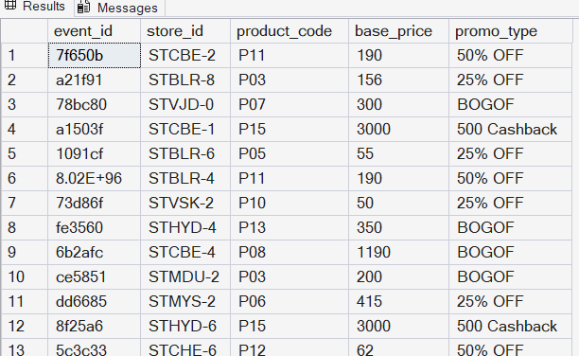
- D Sorting Promotional Events
Display all events where quantity sold after the promotion was greater than 100.
Display:
- event_id
- product_code
- promo_type
- quantity_sold(before_promo)
- quantity_sold(after_promo)
Sort by quantity_sold(after_promo) in descending order.

Concepts: WHERE, ORDER BY, DESC.
CODE: SELECT event_id, product_code, promo_type, [quantity_sold(before_promo)], [quantity_sold(after_promo)]
FROM fact_events
ORDER BY [quantity_sold(after_promo)] DESC;
OUTPUT:
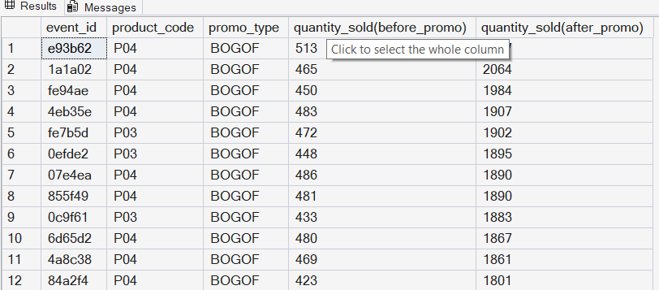
- Find DISTINCT Promotion Types
Find all unique promotion types used in the dataset.
Display only the unique promo_type values.
Concepts: DISTINCT
CODE: SELECT DISTINCT promo_type
FROM fact_events;
OUTPUT:
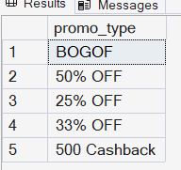
- Basic Aggregation
Calculate the following for the complete fact_events table:
- Total number of events
- Total quantity sold before promotion
- Total quantity sold after promotion
- Average base price
- Maximum base price
- Minimum base price
Return all metrics in one row.
Concepts: COUNT, SUM, AVG, MAX, MIN.
CODE: SELECT COUNT(*) AS [Total number of events], SUM([quantity_sold(before_promo)]) AS [Total quantity sold before promotion], SUM([quantity_sold(after_promo)]) AS [Total quantity sold after promotion], AVG(base_price) AS [Average base price], MAX(base_price) AS [Maximum base price], MIN(base_price) AS [Minimum base price]
FROM fact_events;
OUTPUT:
- Sales Volume by Promotion Type
For each promo_type, calculate:
- Number of events
- Total quantity sold before promotion
- Total quantity sold after promotion
Sort by total quantity sold after promotion in descending order.
Concepts: GROUP BY, COUNT, SUM, ORDER BY.
CODE: SELECT promo_type, COUNT(*) AS [Number of events], SUM([quantity_sold(before_promo)]) AS [Total quantity sold before promotion], SUM([quantity_sold(after_promo)]) AS [Total quantity sold after promotion]
FROM fact_events
GROUP BY promo_type
ORDER BY [Total quantity sold after promotion] DESC;
OUTPUT:
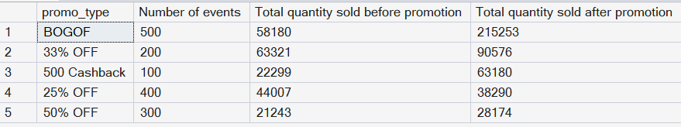
- Promotion Uplift
For every promotion type, calculate:
- Total quantity before promotion
- Total quantity after promotion
- Quantity increase/decrease

Use:
Quantity Change = After Promo Quantity - Before Promo Quantity
Display:
- promo_type
- total_before
- total_after
- quantity_change
Sort by quantity_change descending.
Concepts: GROUP BY, SUM, arithmetic calculations, aliases.
CODE: SELECT promo_type, SUM([quantity_sold(before_promo)]) AS [total_before], SUM([quantity_sold(after_promo)]) AS [total_after], SUM([quantity_sold(after_promo)])-SUM([quantity_sold(before_promo)]) AS [quantity_change]
FROM fact_events
GROUP BY promo_type
ORDER BY [quantity_change] DESC;
OUTPUT:
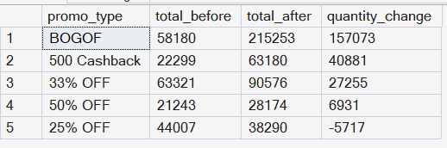
- Using roduct Performance
Using fact_events and dim_products, calculate total quantity sold after promotion for every product.

Display:
- product_code
- product_name
- category
- total quantity after promotion
Sort by total quantity after promotion descending.
Concepts: INNER JOIN, GROUP BY, SUM, ORDER BY
CODE: SELECT p.product_code, p.product_name, p.category, SUM(e.[quantity_sold(after_promo)]) AS [total quantity after promotion]
FROM fact_events e INNER JOIN dim_products p ON e.product_code = p.product_code
GROUP BY p.product_code, p.product_name, p.category
ORDER BY [total quantity after promotion] DESC;
OUTPUT:
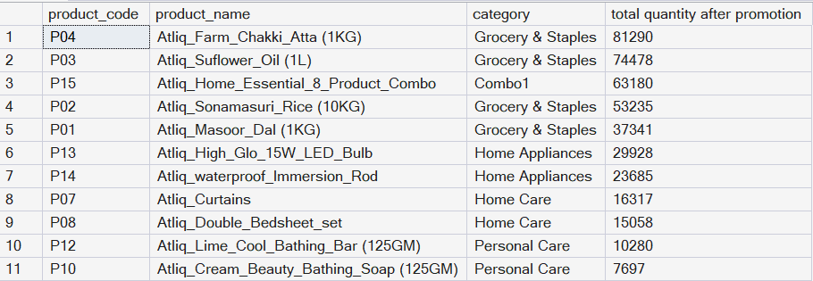

- GGFUsing fact_events and dim_products, calculate for every product category:
- Number of events
- Total quantity before promotion
- Total quantity after promotion
- Quantity change
Sort categories by total quantity after promotion descending.
Concepts: JOIN, GROUP BY, SUM, COUNT, arithmetic calculations.
CODE: SELECT p.category, COUNT(e.event_id) AS [Number of events], SUM(e.[quantity_sold(before_promo)]) AS [Total quantity before promotion], SUM(e.[quantity_sold(after_promo)]) AS [Total quantity after promotion], SUM(e.[quantity_sold(after_promo)])-SUM(e.[quantity_sold(before_promo)]) AS [Quantity_change]
FROM fact_events e INNER JOIN dim_products p ON e.product_code = p.product_code
GROUP BY p.category
ORDER BY [Total quantity after promotion] DESC;
OUTPUT:
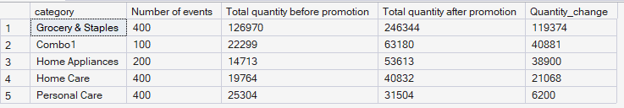
- Store Performance
Using fact_events and dim_stores, calculate for every city:
- Number of promotional events
- Total quantity before promotion
- Total quantity after promotion
Display:
- city
- event_count
- total_before
- total_after
Sort cities by total_after descending.
Concepts: JOIN, GROUP BY, aggregation, ORDER BY.
CODE: SELECT s.city, COUNT(e.event_id) AS [event_count], SUM(e.[quantity_sold(before_promo)]) AS [total_before], SUM(e.[quantity_sold(after_promo)]) AS [total_after]
FROM dim_stores s INNER JOIN fact_events e ON s.store_id = e.store_id
GROUP BY s.city
ORDER BY [total_after] DESC;
OUTPUT:
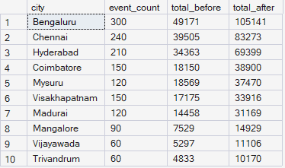
- Campaign Performance
Using fact_events and dim_campaigns, calculate for each campaign:
- Campaign name
- Start date
- End date
- Number of events
- Total quantity before promotion
- Total quantity after promotion
Sort by total quantity after promotion descending.
Concepts: JOIN, GROUP BY, date columns, aggregation.
CODE: SELECT c.campaign_name, c.start_date, c.end_date, COUNT(e.event_id) AS [Number of events], SUM(e.[quantity_sold(before_promo)]) AS [Total quantity before promotion], SUM(e.[quantity_sold(after_promo)]) AS [Total quantity after promotion]
FROM dim_campaigns c INNER JOIN fact_events e ON c.campaign_id = e.campaign_id
GROUP BY c.campaign_name, c.start_date, c.end_date
ORDER BY [Total quantity after promotion] DESC;
OUTPUT:

- Product Category with HAVING
Find product categories where the total quantity sold after promotion is greater than 1,000.
Display:
- category
- total quantity after promotion
- average base price
Sort by total quantity after promotion descending.
Concepts: JOIN, GROUP BY, HAVING, AVG, SUM.
CODE: SELECT p.category, SUM(e.[quantity_sold(after_promo)]) AS [Total quantity after promotion], AVG(base_price) AS [average base price]
FROM fact_events e INNER JOIN dim_products p ON e.product_code = p.product_code
GROUP BY p.category
HAVING SUM(e.[quantity_sold(after_promo)]) > 1000
ORDER BY [Total quantity after promotion] DESC;
OUTPUT:
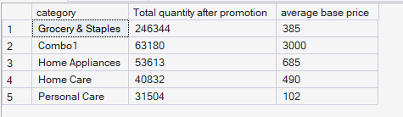
- Store + Category Analysis
Using fact_events, dim_stores and dim_products, calculate total quantity sold after promotion for every combination of:
- City
- Product category
Display:
- city
- category
- total quantity after promotion
Sort first by city and then by total quantity descending.
Concepts: Multiple JOINs, GROUP BY, ORDER BY.
CODE: SELECT s.city, p.category, SUM(e.[quantity_sold(after_promo)]) AS [Total quantity after promotion]
FROM fact_events e INNER JOIN dim_products p ON e.product_code = p.product_code
INNER JOIN dim_stores s ON s.store_id = e.store_id
GROUP BY s.city, p.category
ORDER BY [Total quantity after promotion] DESC;
OUTPUT:
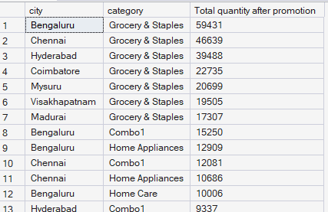
- Promotion Effectiveness by Product
For each product, calculate:
- Product name
- Category
- Total quantity before promotion
- Total quantity after promotion
- Quantity change
- Percentage change
Use:
Percentage Change = ((After Promo - Before Promo) / Before Promo) * 100
Handle division by zero appropriately.
Sort by percentage change descending.
Concepts: JOIN, GROUP BY, arithmetic calculations, NULLIF, percentage calculations.
CODE: SELECT p.product_name, p.category, SUM(e.[quantity_sold(before_promo)]) AS [Total quantity before promotion], SUM(e.[quantity_sold(after_promo)]) AS [Total quantity after promotion], SUM(e.[quantity_sold(after_promo)])-SUM(e.[quantity_sold(before_promo)]) AS [Quantity_change], ((SUM(e.[quantity_sold(after_promo)])- SUM(e.[quantity_sold(before_promo)])) * 100/ NULLIF(SUM(e.[quantity_sold(before_promo)]),0)) AS [Percentage change]
FROM fact_events e INNER JOIN dim_products p ON e.product_code = p.product_code
GROUP BY p.product_name, p.category
ORDER BY [Percentage change] DESC;
OUTPUT:
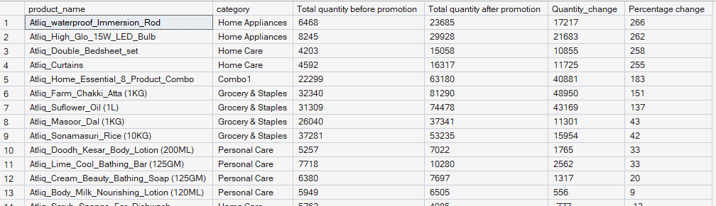
- Campaign and Promotion Type Analysis
For each campaign and promo_type combination, calculate:
- Number of events
- Total quantity before promotion
- Total quantity after promotion
- Quantity change
Display:
- campaign_name
- promo_type
- event_count
- total_before
- total_after
- quantity_change
Sort by campaign_name and quantity_change descending.
Concepts: Multiple GROUP BY columns, JOIN, aggregation, ORDER BY.
CODE: SELECT c.campaign_name, e.promo_type, COUNT(e.event_id) AS [event_count], SUM(e.[quantity_sold(before_promo)]) AS [total_before], SUM(e.[quantity_sold(after_promo)]) AS [total_after], SUM(e.[quantity_sold(after_promo)])-SUM(e.[quantity_sold(before_promo)]) AS [Quantity_change]
FROM dim_campaigns c INNER JOIN fact_events e ON c.campaign_id = e.campaign_id
GROUP BY c.campaign_name, e.promo_type
ORDER BY c.campaign_name ASC, [Quantity_change] DESC;

OUTPUT:
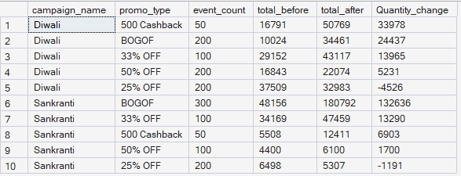
- Product Revenue Before and After Promotion
For each product, calculate:
1. Revenue before promotion = base_price × quantity_sold(before_promo)
2. Revenue after promotion = base_price × quantity_sold(after_promo)
3. Revenue difference = Revenue after - Revenue before
Display:
- product_name
- category
- revenue_before
- revenue_after
- revenue_difference
Sort by revenue_difference descending.
Concepts: JOIN, GROUP BY, SUM, arithmetic calculations, aliases.
CODE: SELECT p.product_name, p.category, SUM(e.base_price*e.[quantity_sold(before_promo)]) AS [revenue_before], SUM(e.base_price*e.[quantity_sold(after_promo)]) AS [revenue_after], SUM(e.base_price*e.[quantity_sold(after_promo)]) - SUM(e.base_price*e.[quantity_sold(before_promo)]) AS [revenue_difference]
FROM fact_events e INNER JOIN dim_products p ON e.product_code = p.product_code
GROUP BY p.product_name, p.category
ORDER BY [revenue_difference] DESC;
OUTPUT:
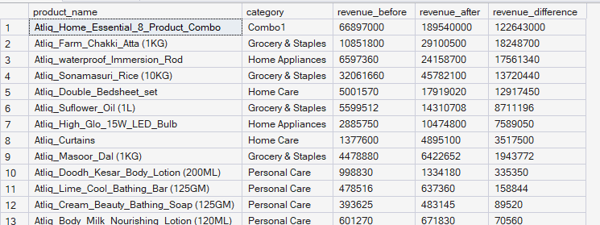
- Classify Promotion Performance
For every promotion type, calculate total quantity before and after promotion.
Then classify the promotion using CASE:
- Percentage change >= 50% → "High Impact"
- Percentage change >= 20% → "Medium Impact"
- Percentage change < 20% → "Low Impact"
Display:
- promo_type
- total_before
- total_after
- percentage_change
- performance_category
Sort by percentage_change descending.
Concepts: GROUP BY, CASE, arithmetic calculations, NULLIF, aliases.

CODE: WITH temp AS (
SELECT promo_type, SUM([quantity_sold(before_promo)]) AS [total_before], SUM([quantity_sold(after_promo)]) AS [total_after], ((SUM([quantity_sold(after_promo)])- SUM([quantity_sold(before_promo)])) * 100/ NULLIF(SUM([quantity_sold(before_promo)]),0)) AS [percentage_change]
FROM fact_events
GROUP BY promo_type
)
SELECT promo_type, [total_before], [total_after], [percentage_change], CASE WHEN [percentage_change] >= 50 THEN 'High Impact' WHEN [percentage_change] >= 20 THEN 'Medium Impact' ELSE 'No Impact' END AS [performance_category]
FROM temp
ORDER BY [percentage_change] DESC;
OUTPUT:
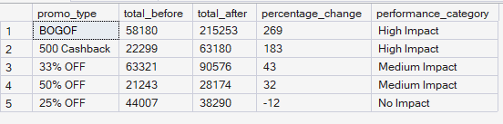
- Top Products Within Each Category
Using a CTE:
1. Calculate total quantity sold after promotion for every product.
2. Rank products within each category based on total quantity sold after promotion.
3. Return only the top 2 products from every category.
Display:
- category
- product_name
- total_quantity_after
- category_rank
Concepts: CTE, JOIN, GROUP BY, DENSE_RANK/ROW_NUMBER, PARTITION BY, window functions.
CODE: WITH temp AS (
SELECT p.category, p.product_name, SUM(e.[quantity_sold(after_promo)]) AS [total_quantity_after], RANK() OVER (PARTITION BY p.category ORDER BY SUM(e.[quantity_sold(after_promo)]) DESC) AS [category_rank]
FROM fact_events e INNER JOIN dim_products p ON e.product_code = p.product_code
GROUP BY p.category, p.product_name
)
SELECT category, product_name, total_quantity_after, category_rank
FROM temp
WHERE category_rank <= 2;
OUTPUT:
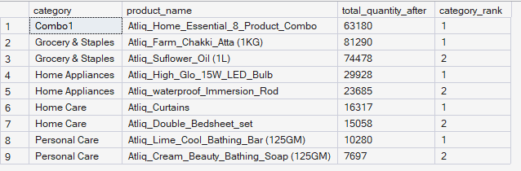
- Best-Performing Stores Within Each City
Calculate total quantity sold after promotion for each store.
Join dim_stores to obtain the city.
Then rank stores within each city based on total quantity sold after promotion.
Return the top 2 stores from each city.
Display:
- city
- store_id
- total_quantity_after
- city_rank
Concepts: JOIN, CTE, GROUP BY, window functions, PARTITION BY, RANK/DENSE_RANK.
CODE: WITH temp AS (
SELECT s.city, s.store_id, SUM(e.[quantity_sold(after_promo)]) AS [total_quantity_after], RANK() OVER (PARTITION BY s.city ORDER BY SUM(e.[quantity_sold(after_promo)]) DESC) AS [city_rank]
FROM dim_stores s INNER JOIN fact_events e ON s.store_id = e.store_id
GROUP BY s.city, s.store_id
)
SELECT city, store_id, [total_quantity_after], [city_rank]
FROM temp
WHERE [city_rank] <= 2;
OUTPUT:
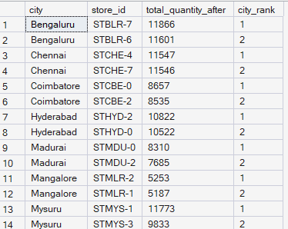
- Campaign-Level Product Performance
For every campaign and product:
Calculate:
- Total quantity before promotion
- Total quantity after promotion
- Quantity change
- Percentage change
Then rank products within each campaign based on percentage change.
Return the top 3 products for every campaign.
Display:
- campaign_name
- product_name
- total_before
- total_after
- quantity_change
- percentage_change
- campaign_rank
Concepts: Multiple JOINs, CTE, GROUP BY, arithmetic calculations, NULLIF, window functions, PARTITION BY, ranking.
CODE: WITH temp1 AS (
SELECT c.campaign_name, p.product_name, SUM(e.[quantity_sold(before_promo)]) AS [total_before], SUM(e.[quantity_sold(after_promo)]) AS [total_after], SUM(e.[quantity_sold(after_promo)])-SUM(e.[quantity_sold(before_promo)]) AS [Quantity_change], ((SUM(e.[quantity_sold(after_promo)])- SUM(e.[quantity_sold(before_promo)])) * 100/ NULLIF(SUM(e.[quantity_sold(before_promo)]),0)) AS [percentage_change]
FROM dim_campaigns c INNER JOIN fact_events e ON c.campaign_id = e.campaign_id INNER JOIN dim_products p ON p.product_code = e.product_code
GROUP BY c.campaign_name, p.product_name
),
temp2 AS (
SELECT campaign_name, product_name, total_before, total_after, quantity_change, percentage_change, DENSE_RANK() OVER (PARTITION BY campaign_name ORDER BY percentage_change DESC) AS campaign_rank
FROM temp1
)
SELECT campaign_name, product_name, total_before, total_after, quantity_change, percentage_change, campaign_rank
FROM temp2
WHERE campaign_rank <=3;
OUTPUT:
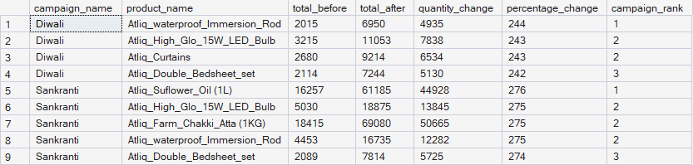
- GH Complete Promotional Performance Analysis
Create a complete analytical report at the product-category level.
For every product, calculate:
- Product name
- Category
- Number of promotional events
- Total quantity before promotion
- Total quantity after promotion
- Quantity change
- Percentage change
- Revenue before promotion
- Revenue after promotion
- Revenue change
- Average base price
- Product rank within its category
Use:
Quantity Change = Total After - Total Before
Percentage Change = ((Total After - Total Before) / Total Before) * 100
Revenue Before = SUM(base_price × quantity_before)
Revenue After = SUM(base_price × quantity_after)
Revenue Change = Revenue After - Revenue Before
Then:
1. Rank products within each category by Revenue Change.
2. Return only the top 2 products from each category.
3. Use appropriate handling for division by zero.
Concepts:
- Multiple JOINs
- CTEs
- GROUP BY
- COUNT
- SUM
- AVG
- CASE
- NULLIF
- Arithmetic calculations
- Percentage calculations
- Window functions
- PARTITION BY
- DENSE_RANK / ROW_NUMBER
- Filtering ranked results
- Business analysis
CODE: WITH temp AS (
SELECT p.product_name, p.category, COUNT(e.promo_type) AS [Number of promotional events], SUM(e.[quantity_sold(before_promo)]) AS [Total quantity before promotion], SUM(e.[quantity_sold(after_promo)]) AS [Total quantity after promotion], SUM(e.[quantity_sold(after_promo)]) - SUM(e.[quantity_sold(before_promo)]) AS [Quantity change], SUM(e.[quantity_sold(after_promo)])- SUM(e.[quantity_sold(before_promo)])) * 100/ NULLIF(SUM(e.[quantity_sold(before_promo)]),0)) AS [percentage_change], SUM(e.base_price*e.[quantity_sold(before_promo)]) AS [Revenue before promotion], SUM(e.base_price*e.[quantity_sold(after_promo)]) AS [Revenue after promotion], SUM(e.base_price*e.[quantity_sold(after_promo)]) - SUM(e.base_price*e.[quantity_sold(before_promo)]) AS [Revenue Change], DENSE_RANK() OVER (PARTITION BY p.category ORDER BY (SUM(e.base_price*e.[quantity_sold(after_promo)]) - SUM(e.base_price*e.[quantity_sold(before_promo)])) DESC) AS [Product Rank]
FROM dim_products p INNER JOIN fact_events e ON p.product_code = e.product_code
GROUP BY p.product_name, p.category
)
SELECT product_name, category, [Number of promotional events], [Total quantity before promotion], [Total quantity after promotion], [Quantity change], [percentage_change], [Revenue before promotion], [Revenue after promotion], [Revenue Change], [Product Rank]
FROM temp
WHERE [Product Rank] <= 2;
OUTPUT:
